**DEPARTAMENTO DE BIOQUÍMICA**



# FACULTAD DE MEDICINA

Sep 10, 2022

Prof. Dr. Farid Chemat

Guest Editor

*Molecules*

Dears Professor Farid Chemat:

We are enclosing a manuscript entitled **Bisindolylmaleimides new inhibitors of CaM protein**by Alejandro Sosa-Peinado, Karina Fructuoso-García, Luz Vasquez-Bochm, and Martin González-Andrade. We would like this paper to be considered for possible publication in *molecules*.

Herein, we reported the interactions at the molecular level of a series of compounds called Bisindol-ylmaleimide, as potential inhibitors of the calmodulin protein. Bisindolylmaleimide compounds are drug prototypes derived from *Staurosporine*, an alkaloid with activity for cancer treatment. Bisindolylmaleimide compounds II, IV, VII, X, and XI, are proposed and reported as new inhibitors of calmodulin protein for the first time. For the above, a biotechnological device was used (fluorescent biosensor *h*CaM M124C-*mBBr*) to directly determine binding parameters experimentally (*K*d and stoichiometry) of these compounds, and molecular modeling tools (Docking, Molecular Dynamics, and Chemoinformatic Analysis) to carry out the theoretical studies and complement the experimental data. The results indicate that this compound binds to calmodulin with a *K*d between 193-248 nM, an order of magnitude lower than most classic inhibitors. On the other hand, the theoretical studies support the experimental results, obtaining an acceptable correlation between the GExperimental and GTheoretical (r2=0.703) and providing us with complementary molecular details of the interaction between the calmodulin protein and the Bisindolylmaleimide series. Chemoinformatic analyzes bring certainty to Bisindolylmaleimide compounds to address clinical steps in drug development. So, these results make these compounds attractive to be considered as possible prototypes of new calmodulin protein inhibitors.

With my personal best regards.

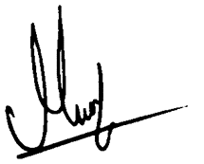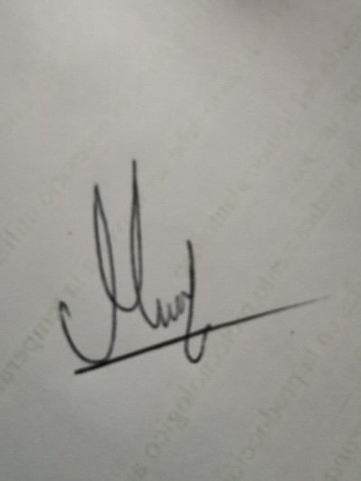

Dr. Martin González